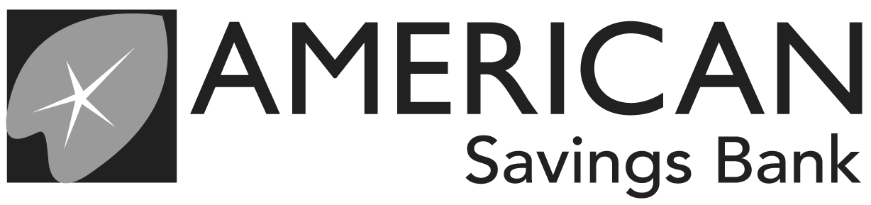

WIRE TRANSFER REQUEST
Branch Name |  |  |  |  |  | Date/Time Received |  |  | 7/28/26 11:49:41 AM
Branch Number |  |  |  |  |  | Date to Be Sent |  |  | / /
Accepted By |  |  |  |  |  | Wire Amount
Template # |  |  |  |  |  | Fee Amount |  |  | $
SENDING BANK INFORMATION |  |  |  |  |  | RECEIVING BANK INFORMATION
Bank ABA # | 321370765 |  |  |  |  | Bank ABA #
ORIGINATOR INFORMATION |  |  |  |  |  | BENEFICIARY (PAYEE) INFORMATION
Name |  |  |  |  |  | Name
Account # |  |  |  |  |  | Account #
Address 1 |  |  |  |  |  | Address 1
Address 2 |  |  |  |  |  | Address 2
City, State, Zip |  |  |  |  |  | City, State, Zip
DL, TIN, Passport |  |  |  |  |  | Country
Phone/Cell Number |  |  |  |  |  | DL, TIN, Passport
Wire Purpose and Relationship to Beneficiary (payee): |  |  |  |  |  | Phone Number
BENEFICIARY BANK INFORMATION |  |  |  |  |  | INTERMEDIARY BANK INFORMATION
Bank Name |  |  |  |  |  | Bank Name
ABA # or SWIFT |  |  |  |  |  | ABA # or SWIFT
Address 1 |  |  |  |  |  | Address 1
Address 2 |  |  |  |  |  | Address 2
City, State, Zip |  |  |  |  |  | City, State, Zip
Country |  |  |  |  |  | Country
ORIGINATOR TO BENEFICIARY INSTRUCTIONS (Maximum 140 Characters)
AGREEMENT
By signing below, I/we agree with the terms of the Wire Funds Transfer Agreement on the back of this form.
❒ |  |  |  | / / |  |  | ❒ |  |  |  |  | / /
Originator Signature |  |  |  | Date |  |  | Originator Signature (if applicable) |  |  |  |  | Date
FOR BANK USE ONLY
Approved By: (Print Name, Sign, Phone/Ext #) |  |  |  |  |  |  | Callback Verification With: (if applicable)
Entered By: |  | Verified By: |  |  | Reference #: |  |  | Date Processed: |  | Verified With:

WIRE FUNDS TRANSFER AGREEMENT

Requests to transfer funds are generally governed by Uniform Commercial Code – Funds Transfers, Haw. Rev. Stat. Ch. 490:4A. American Savings Bank, F.S.B. is referred to here as “ASB”, "we", "us", or "our,", and the terms "Bank", "Beneficiary", "Funds Transfer", "Funds Transfer Business Day", "Intermediary Bank" and "Payment Order" are used here as they are defined in Ch. 490:4A.

Fedwire
Fedwire is the funds transfer system of the U.S. Federal Reserve Bank. While we may select any Intermediary Bank, Funds Transfer System, or other reasonable means of transmittal to send your Payment Order (even if you specify a different method), we may use Fedwire when you send us a Payment Order. Other Banks involved in the
Funds Transfer may use Fedwire as well. Any Funds Transfers carried by Fedwire will be governed by Regulation J of the Federal Reserve Board. All Funds Transfers we make will be subject to Federal laws and regulations, ASB’s rules, policies and procedures, state laws and regulations, and general banking practice in Hawaii.

Responsibility
You are responsible for the contents of each Wire Transfer Request sent to or through us. We are not responsible for the detection of errors contained in any request and are entitled to rely on the information provided to us. We, and any other Bank executing a Payment Order, may rely: (a) on the number in the Payment Order that identifies a party, even if it is different from the party named as the Beneficiary; and (b) on the name and number of an Intermediary or Beneficiary Bank named in the transfer instructions, even if the name or number identifies different parties. We and any other Intermediary or Beneficiary Bank have no obligation to determine whether the name and number identify the same persons. Errors must be reported to us not more than ninety (90) days after payment of the relevant transfer instruction was processed. Except as otherwise provided by law, failure to notify us of the errors relieves us of any liability for damages or loss caused by the transaction.

Liability
We shall be liable only for our failure to act to the extent set out in this agreement with you unless otherwise provided by law. We shall not be liable for loss or damage for circumstances beyond our reasonable control, for equipment failure or if you have failed to notify us of any error in any transfer within the time period required for prior notice, if any. We shall not be liable for punitive, special, indirect or consequential damages even if we have been advised of such damages. We are not responsible for the fees, offsets, acts, or failure to act of any other person, including without limitation, any Intermediary Bank, our correspondent, any Federal Reserve Bank, the Funds Transfer network, other Banks involved in the transfer, or the ultimate payer Bank (including the failure of the payer Bank to identify or pay the Beneficiary), and by signing on the reverse of this form, you agree to indemnify and hold American Savings Bank harmless for the same. We do not control the fees or collection methodologies of intermediary or beneficiary banks. Intermediary or beneficiary banks sometimes deduct their fees directly from the wire amount.

Cutoff Times
We have established deadlines or cutoff times on Funds Transfer Business Days for receiving and processing Payment Orders and related communications. The cutoff times may be changed from time to time without prior notice to you and may vary depending upon the branch and type of Payment Order. The cutoff time to cancel or amend a payment order is 3:00 p.m. Hawaii Standard Time on the Funds Transfer Business Day before the value date (the date the funds are to be credited to the Beneficiary). This means that for same-day Fedwire transactions, amendment or cancellation will not be possible. We have no obligation to cancel or amend a Payment Order after we accept it. We shall not be liable for any reason for failure to amend or cancel a Payment Order we have accepted. You agree to reimburse us for any losses, costs or damages we incur in connection with your request to amend or cancel a Payment Order.

Execution
We will initiate the execution of your completed Wire Transfer Request if there are sufficient available balance in your account to cover the amount of the Payment Order and any applicable fee. . If we are unable to execute or accept your Wire Transfer Request, we may give you notice of rejection by any means we select, including orally. We are not liable for any rejection, and we are not obligated to pay you interest for any period before you receive the notice of rejection. If we cannot execute a Payment Order because of circumstances beyond our reasonable control, we will, without prior notice to you, execute the Payment Order on the next Business Day, if then possible. If we complete a Payment Order request which results in an overdraft to your account, we may charge you an overdraft fee in effect at that time. If we must refer the collection of the overdraft to an agency, you will be responsible for reasonable fees and costs.

